Morphological Lexicon

What is Morphological Lexicon
# Source: Chatgpt (GPT-4-turbo) at [7/29/2025]
A Morphological Lexicon is a specialized lexicon that focuses on the internal structure of words, particularly how roots, stems, and affixes combine to form inflected or derived forms. It is essential in fields like morphology, computational linguistics, and natural language processing (NLP) for handling word formation and grammatical variation.

🔹 Key Features of a Morphological Lexicon
# Source: Chatgpt (GPT-4-turbo) at [7/29/2025]
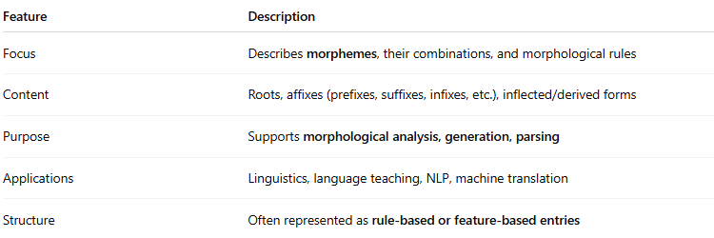
Feature | Description
Focus | Describes morphemes, their combinations, and morphological rules
Content | Roots, affixes (prefixes, suffixes, infixes, etc.), inflected/derived forms
Purpose | Supports morphological analysis, generation, parsing
Applications | Linguistics, language teaching, NLP, machine translation
Structure | Often represented as rule-based or feature-based entries

🔹 What It Includes
# Source: Chatgpt (GPT-4-turbo) at [7/29/2025]
- Lexeme: Base unit of meaning (e.g., run)
- Inflectional forms: run, runs, ran, running
- Derivational forms: runner, running, rerun
- Morphological rules:
  - Verb + -ing → Present participle
  - Noun + -s → Plural
- Morpheme entries:
  - Prefixes (un-, re-),
  - Suffixes (-ness, -able),
  - Roots (dict, bio, cred)

🔹 Examples of Morphological Lexicons
# Source: Chatgpt (GPT-4-turbo) at [7/29/2025]
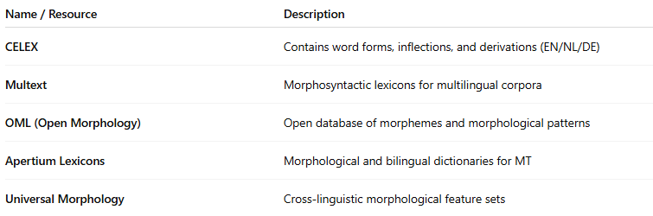
Name / Resource | Description
CELEX | Contains word forms, inflections, and derivations (EN/NL/DE)
Multext | Morphosyntactic lexicons for multilingual corpora
OML (Open Morphology) | Open database of morphemes and morphological patterns
Apertium Lexicons | Morphological and bilingual dictionaries for MT
Universal Morphology | Cross-linguistic morphological feature sets

🔹 Morphological vs Other Lexicons
# Source: Chatgpt (GPT-4-turbo) at [7/29/2025]
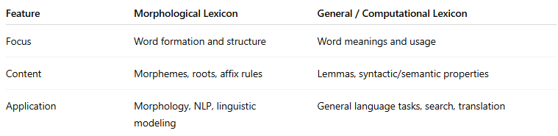
Feature | Morphological Lexicon | General / Computational Lexicon
Focus | Word formation and structure | Word meanings and usage
Content | Morphemes, roots, affix rules | Lemmas, syntactic/semantic properties
Application | Morphology, NLP, linguistic modeling | General language tasks, search, translation

🔹 Applications
# Source: Chatgpt (GPT-4-turbo) at [7/29/2025]
- Spell checking / correction
- Automatic word generation
- Stemming and lemmatization
- Parsing and grammar checkers
- Inflectional pattern analysis (e.g., verb conjugations)

